

# **Automated Test Tools for GUIs**

**User Manual**

**Prepared by: *The Fire Ants***

**Version: 1.1**

**Date: *12/18/2019***

**Sponsors: *Chris Bartley & Michelle Darby, ASRC***

# **Document History**

|  |  |  |  |
| --- | --- | --- | --- |
| **Version** | **Date** | **Updated By** | **Comments** |
| 1.0 | *12/18/2019* | *Julio Crespo* | First Draft |

# **Table of contents**

**Automated Test Tools for GUIs** 0

**Document History** 1

**Table of contents** 2

**General information** 3

System overview 3

Project References 4

Organazation of the manual 5

Acronyms, Abbreviations, and Glossary of Terms 5

***System Summary*** 7

System Configuration 9

Class diagram 9

System requirements 10

**Getting started** 11

Download the GUI Automated Testing From GitHub 11

Running 11

**Appendix** 12

Download Redhat 12

Downloading the virtual box 13

Setting up a Virtual Machine (VM) in VirtualBox 14

Setting up redhat enviroment 20

Install Red Hat via VirtualBox 20

Removing the ISO file so it does not start the installation process again 23

Setting up Internet Access if it was not done during Installing phase 24

In Red Hat 7 24

In Red Hat 8 25

Setting up GUI for Red Hat 7 25

Making sure Red Hat is updated 25

Subscribing to Repository. 25

Install Motif and X11 25

Installing Addintional Library 25

To drag and drop files from Home OS to Red Hat 25

Setting up a share Directory (AKA folder) 27

Setting up GoogleTest Library and GoogleMock Library 27

Recommand Program With Google Test Framework 28

Installing crpcut 28

# **General information**

## System overview

1. Our system provides users with a way to record their mouse movements and keystrokes into an XML file which is given to Google Test. Google Test will then perform automated testing without the assistance of a dedicated user, thereby reducing labor hours spent on testing GUIs in the display department
2. In its current version, the application does the following:
   1. Users are greeted with a GUI that will start the mouse tracker
      1. The GUI has the following widgets that the user can choose to test, push button, radio button, scroll bar, text box
   2. The mouse tracker tracks keystrokes, mouse clicks, mouse movement
   3. The mouse tracker saves the events into a file
3. In addition, there is support for the following:
   1. Installing RedHat on a Virtual Machine
   2. Compiling C++ code that uses the Motif toolkit
   3. Installing and running Google Mock and Google Test on RedHat
   4. Making “makefile”
4. The application still requires the following:
   1. Turning recorded events into an XML file
   2. A C++ tool that will read an XML file
   3. Mocking a GUI using GoogleMock
   4. Using the XML file to test a mocked GUI on Google Test
5. The final application should record user input for testing GUIs into an XML file. Google Mock will mock the intended GUI. Google Test will then take the XML file and perform automated testing on the mocked GUI. The result is a printout of pass and/or fail based on assertions on how a GUI should perform written in the Google Test framework.
6. This system serves to reduce testing labor in the Display Department of ASRC as the final product would not require a user to be present while the program performs its tests. Only the initial recording of mouse movements requires the user’s input.

## Project References

We highly suggest the following to future developers in order to understand the implementation of Motif in C++.

Object-Oriented Programming with C++ and OSF/Motif 2nd Edition by Douglas A. Young

Definitive guide to the X Window guide: Motif Programming Manual vol. 6A Dan Heller and Paula M. Fergusa

Definitive guide to the X Window guide: X Toolkit Intrinsics programming manual V4 By Adrian Nye and Tim O'Reilly

UIM/X Beginner Guide by Integrated Computer Solutions, Inc. 2005-2007

Brochard, Adrien. “How to Simulate Key Press and Mouse Movement in Linux.” Xmodulo, 10 July 2014,<http://xmodulo.com/simulate-key-press-mouse-movement-linux.html>.

Sissel, Jordan. “Xdotool - Fake Keyboard/Mouse Input, Window Management, and More.” Semicomplete, 24 Apr. 1970,<https://www.semicomplete.com/projects/xdotool/>.

crpcut-1.3.2 documentation <http://crpcut.sourceforge.net/1.3.2/index.html>

## Organazation of the manual

This manual is divided into parts. These are: General Information, System Overview, and Getting Started.

**General** **Information** – The purpose of this section is to introduce the system and its capabilities. In addition, the software requirements for running are outlined.

**System** **Summary** – High level overview of the design of the software system in terms of both the software and hardware.

**Getting Started** – A Step-by-Step guide to installing and running the software system.

**Appendix** - Step-by-Step guide to setup the student’s computer to run Automated GUI Testing program.

## Acronyms, Abbreviations, and Glossary of Terms

|  |  |
| --- | --- |
| **Acronym/**  **Defined Term** | **Description** |
| Red Hat | OS required to execute Motif GUIs as well as Google Test/Mock libraries |
| VM Virtual box | Virtual machine used to instantiate Red Hat Linux for software development/testing. |
| GitHub | Web-based hosting service for software development projects that use the Git revision control system |
| Google Mock | Google Mock is an object mocking framework for C++ unit testing. |
| C++ | Programming language chosen for this project. |
| Motif | C based API to realize graphical UI in Linux |
| Google Test | Testing library for the C++ programming language, based on the xUnit architecture. |
| Unit Testing | level of testing where individual units/ components of a software are tested |
| X Windows | A windowing system for bitmap displays, common on Unix-like operating systems. X provides the basic framework for a GUI environment: drawing and moving windows on the display device and interacting with a mouse and keyboard. |
| Makefile | a file containing a set of directives used by a make build automation tool to generate a target/goal. |
| X11 | A windowing system for bitmap displays, common on Unix-like operating systems. X provides the basic framework for a GUI environment: drawing and moving windows on the display device and interacting with a mouse and keyboard. |
| XRecord | This extension is to support the recording and reporting of all core X protocol and arbitrary X extension protocol. |
| X Toolkit intrinsics | X Toolkit Intrinsics is a library that implements an API to facilitate the development of programs with a graphical user interface for the X Window System. It can be used in the C or C++ languages. |
| crpcut | A C++ unit testing system. |

# ***System Summary***

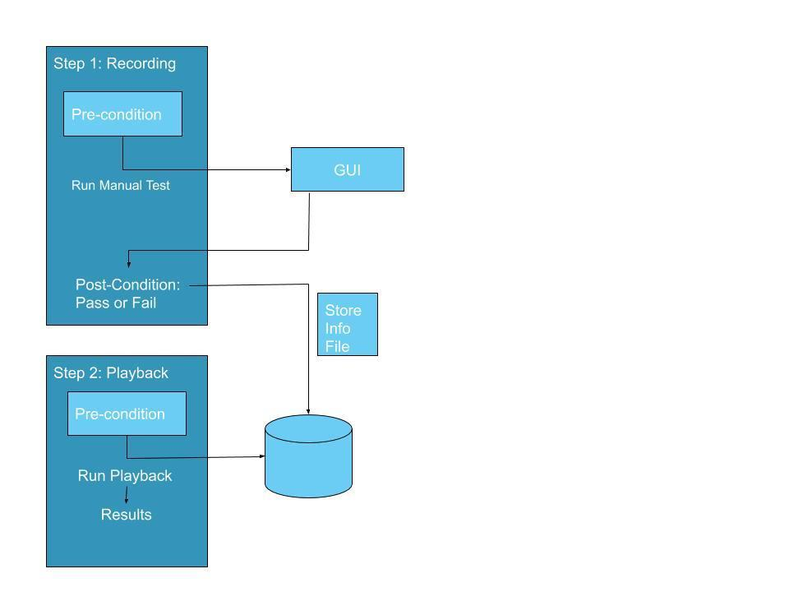

1. The software system described in this manual is responsible for automating testing of C++ GUIs using Motif, Google Test, and C++ libraries with Red Hat as our operating system to increase speed and efficiency and reduce manual testing.

## System Configuration

1. The automated system consists of X11 library, Motif library, C++ library, and Google Test Library and Google Mock Library operating in Red Hat Linux. This can be done via an actual machine hosting Red Hat or a VM emulating the Red Hat environment. This explanation provides a brief overview of the overall configuration and design of the system.

## Class diagram

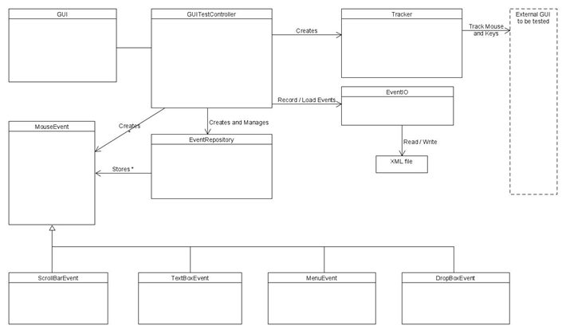

1. The GUI is recording is managed by the GUITestController class. The GUITestController creates a MouseEvent according to the type of event that is given and then is stored in EventRepository.
2. This class diagram shows the structure of the GUITestController and how it is planned to record GUI interactions:

## System requirements

The following is a high-level description of the system requirements and design choices made to fulfill them:

System Requirements:

Recommended:

Requires a 64-bit processor and operating system

OS: 64-bit Linux flavors involving Red Hat

Processor: Intel Core i7 or better

Memory: 8 GB RAM or more

XWindow: Version 11

Storage: 500 GB available space

# **Getting started**

## Download the GUI Automated Testing From GitHub

1. Visit [AFMS GitHub Automated test tool](https://github.com/AFMS-Rowan-Software-Projects/Automated-Test-Tool-for-GUIs-Fall-2019) for GUI to download the GUI automated testing.
2. Place the files in your Red Hat.
3. Open the terminal in the directory where you placed the files in
4. Run the makefile to compile the GUITesterController class.
5. Run “make” to compile code using GoogleTest Library and Google Mock Library.

## Running

1. Type ./GUITest to run GUITest
2. Open a GUI application you wish to record.
3. Select the type of event you wish to record on the GUITest.
4. When finished with action, deselect the event you were recording.
5. Repeat the previous two steps until you are satisfied with all the components you wish to test.

**Note**: You are not able to select a different type event while recording an event.

**Note**: Delete any existing executable of main. You will not have permission to use it. As well the MakeFile will not create a new one as there is an existing main already.

# **Appendix**

## Download Redhat

1. Visit the Red Hat [RHEL Download Page](https://developers.redhat.com/products/rhel/download).
2. Select the Red Hat 7 or newer.
3. Create an account with Red Hat Enterprise.
4. Verify email for your RHEL.
5. Return to the download page and select the DVD ISO hyperlink.

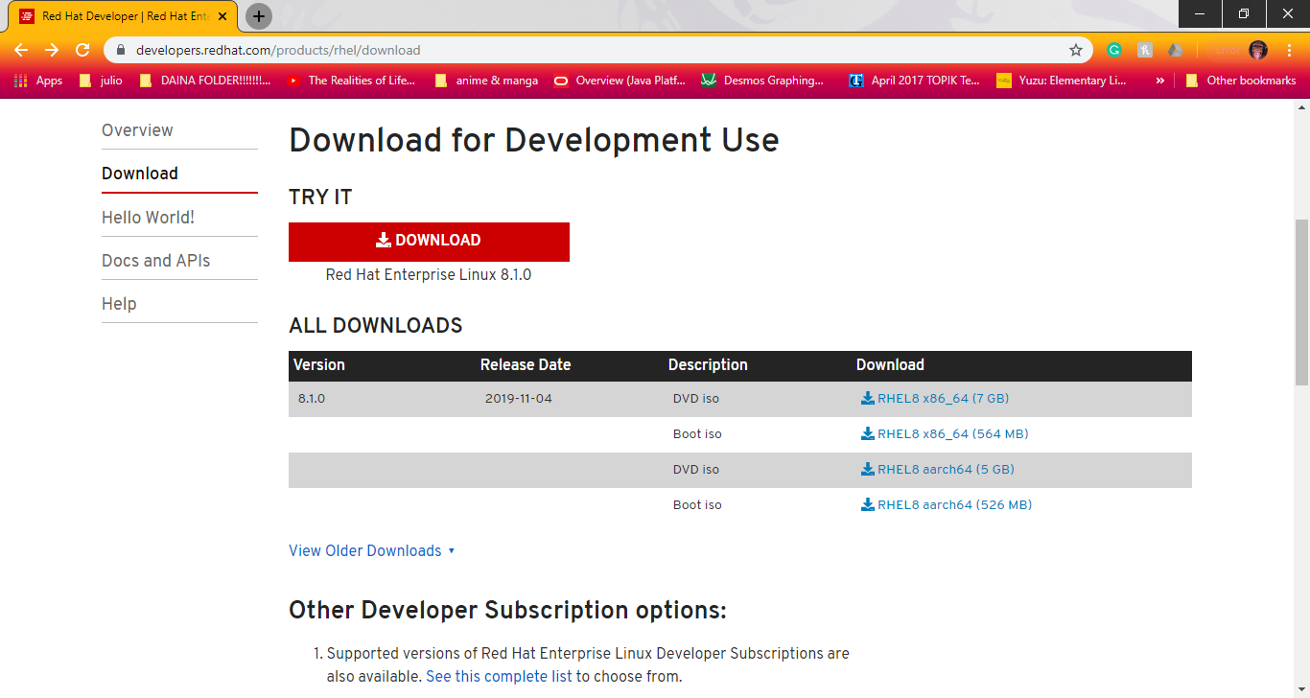

**Note**: selecting the Boot ISO will give you an issue during installation phase of Red Hat where it asks for the source files. We were able to resolve this issue.

1. It will take you another page and start the download page. If any issue arises, please follow the website recommendations.

## Downloading the virtual box

1. Visit the [Virtual Box](https://www.virtualbox.org/wiki/Downloads) Download page.
2. Click the platform package that is compatible to your home system. It will start the download procedure.

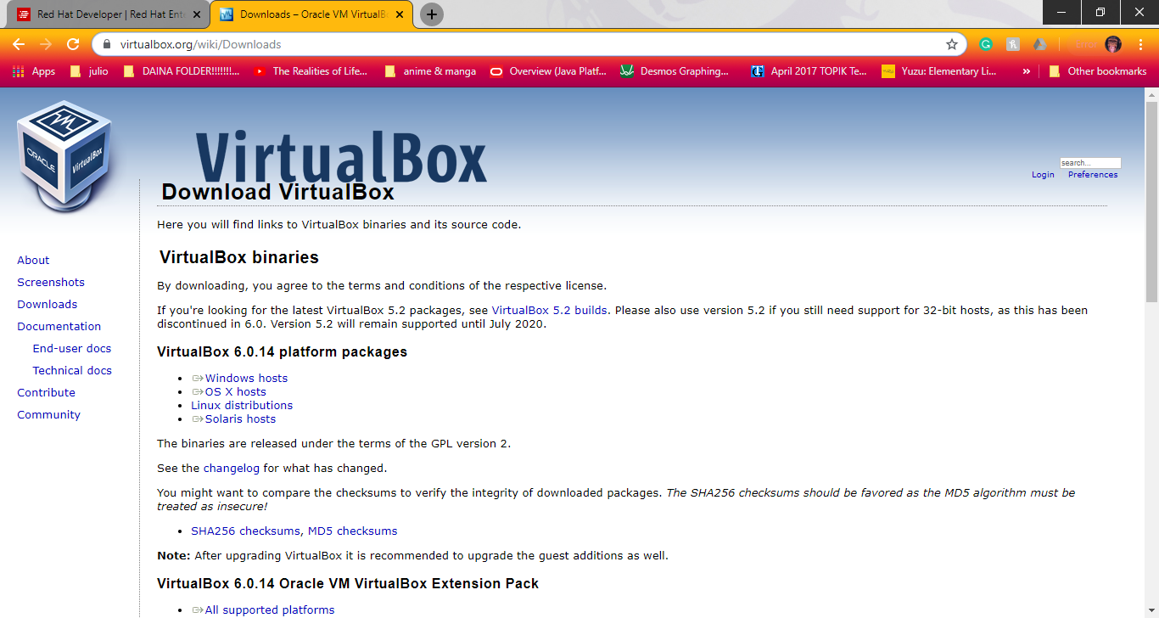

1. When finished downloading, start the install procedure.

## Setting up a Virtual Machine (VM) in VirtualBox

1. Open VirtualBox.
2. Click on New

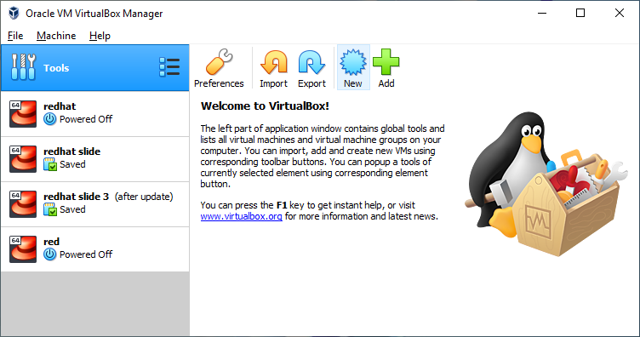

1. In the new window, give a name to your VM.

**Note**: If you name your VM with “redhat,” VirtualBox will edit the type and version to best suit your system.

1. Give about a good amount of RAM to your VM. Click Next.

**Note**: The amount you give depends on your system. You need to give enough RAM so that your VM does not run sluggish. On the contrary, you do not want to give too much RAM or your home OS will suffer. Giving 25% of your system’s RAM should suffice.

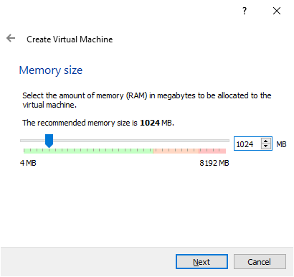

1. Select “Create a virtual hard disk now” and click Create.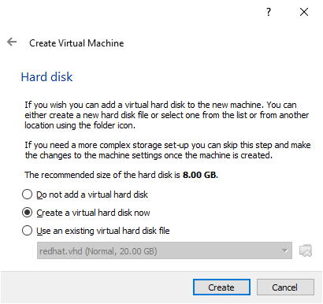
2. Select “VHD (Virtual Hard Disk).” Click “Expert Mode”. 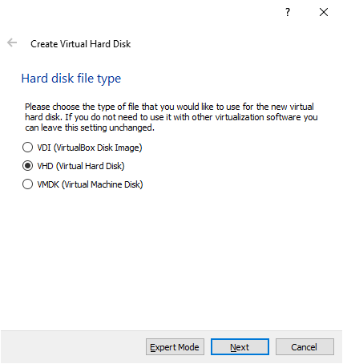
3. Make sure the “VHD (Virtual Hard Disk).” Click “Expert Mode” is selected under “Hard disk file type”. Make sure “Dynamically allocated” is under “Storage on physical hard disk. Click “Create.”

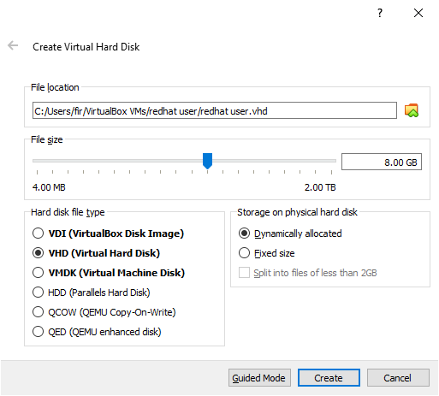

1. VM is created and can be seen on the left side of the window.

**Note**: In this example, I created “redhat user.”

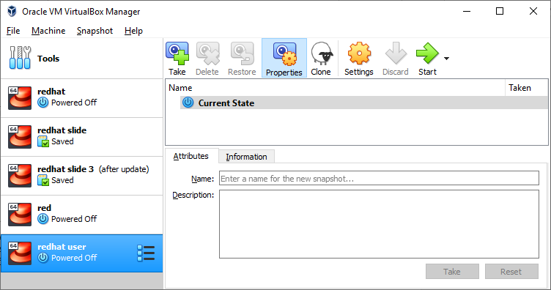

## Setting up redhat enviroment

### Install Red Hat via VirtualBox

1. ISO file that you got from Red Hat download page by clicking the folder with the green arrow pointing up. Click “Start.”

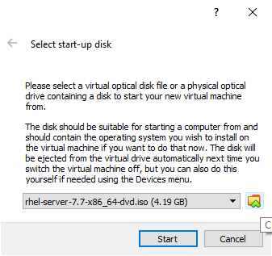

1. The installation process will start. Please wait till you see the language preference screen.

**Note**: you will be working in the VM now. The VM will ask you if it ok to capture your mouse and keyboard while using the VM. **Click Yes. Press Right Ctrl on your keyboard to escape the VM.** Otherwise, you can not use your mouse on your Home OS will you shut down the VM.

1. Select your language preference and click “Continue.” Note: This manual will continue in English.
2. On the Installation Summary page, at first you will see an error item under Software. Red Hat will try to fix that issue. Another issue you will see is under System, Installation Destination. That is a simple fix.

1. Click on Installation Destination and select the HDD that is available on the list. Return Installation Summary.

**Note**: If the installation fails for any reason, the installation process will start over. Throughout this time, the space on the HDD will be taken up by the previous attempt. Just erase the items on the HDD and confirm your action. Reselect the HDD.

1. To set up internet connection, click “NETWORK & HOSTNAME.”
2. You will see an Ethernet connection, flip the switch so it says on. It will be accessing the Home OS internet connection.
3. A.1.4.8 When all issues are settled, click begin Installation. **Note**: If there are issues under software, then a possible cause is you selected the BOOT ISO instead of DVD ISO. Shut Down the VM by closing the window and select the “Power off the Machine.”
4. During installation, make your root account and a user account. Remember the password for each as you will use it later for subscribing to Red Hat repository and installing packages.

### Removing the ISO file so it does not start the installation process again

1. On the VirtualBox window, select the VM without starting it.
2. Go in settings for the VM.
3. Go to Storage.
4. Under Storage Device, Controller: IDE, click the CD with the green plus.
5. In the new window search for VBoxGuestAdditions.iso

**Note**: If you cannot access this, then the VM is stuck in a snapshot. This means VirtualBox saved the state of the machine and stored it in a file. This means that the next time you open the VM, it will be where you left off before closing the VM. You need to open the VM and perform a shutdown.

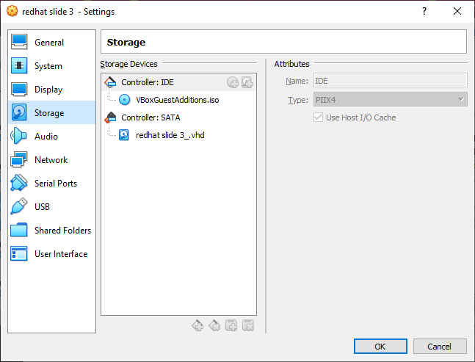

1. You should see a message asking if you trust the VBOXADDITIONS CD.

### Setting up Internet Access if it was not done during Installing phase

#### In Red Hat 7

1. Type in sudo nmtui.
2. Provide the root’s password.
3. Select “Edit a connection.”
4. On the next screen it should show your Ethernet interface marked as “enp0s3”.
5. Click Enter.
6. Press down on your mouse until you are in the checkbox located next to “automatically connect”.
7. Press the spacebar to select it. You can then use your arrow keys to go down to <OK> and then hit enter.
8. Navigate down to “Back” and press enter and then “Quit” and press enter.
9. Type “sudo systemctl restart network” to let Red Hat know that the network adapter is available for use.
10. Provide your sudo password.
11. Verify that the network connection is up and running by typing in “ping –c 2 google.com” and getting a response.

#### In Red Hat 8

1. Click on the drop down arrow. It will display a list.
2. Ethernet should display in the list. Click it and flip the switch to have it say “on.”

### Setting up GUI for Red Hat 7

1. A.1.7.1 Type “sudo yum –y groupinstall “GNOME Desktop”.
2. A.1.7.2 If a black screen is present then press an arrow to get the command line back.
3. A.1.7.3 Type “startx” and provide a language preference on the next screen.
4. A.1.7.4 To avoid typing “startx” everytime you start the machine then type the following:
   1. sudo rm /etc/systemd/system/default.target
   2. sudo ln –sf /lib/systemd/system/graphical.target
   3. /etc/systemd/system/default.target

### Making sure Red Hat is updated

1. Type “sudo yum –y update” and provide root’s password.

### Subscribing to Repository.

1. Either in Red Hat 7 or 8, open the terminal.
2. Type “subscription-manager register” and provide your Red Hat credential (The ones you used to get the Red Hat ISO).
3. Type ”subscription-manager attach --auto” into the same terminal.

### Install Motif and X11

1. Type “sudo yum install *x11* “and then your credentials for the account of the os.
2. Type “sudo yum install *motif* “and then your credentials for the account of the os. V

### Installing Addintional Library

1. Type “sudo yum install libXtst-devel” and then your credentials for the account of the os.

### To drag and drop files from Home OS to Red Hat

1. Type the following Command:

sudo yum –y install kernel-devel

echo export KERN_DIR=/usr/src/kernels/`uname –r` >> ~/.bashrc

reboot

1. When Red Hat rebooted, click on “Devices” on the window bar and select “Insert Guest Additions CD image.”
2. If you get an issue, then shut down the machine.
3. On the VirtualBox window, select the VM without starting it.
4. Go in settings for the VM.
5. Go to Storage.
6. Under Storage Device, Controller: IDE, click the CD with the green plus.
7. In the new window search for VBoxGuestAdditions.iso

**Note**: If you cannot access this, then the VM is stuck in a snapshot which VirtualBox saved the state of the machine and stored it in a file. This means that the next time you open the VM, it will be where you left off before closing the VM. You need to open the VM and perform a shutdown.



1. A.1.11.9 You should see a message asking if you trust the VBOXADDITIONS CD.
2. A.1.11.10 Click run to confirm.
3. A.1.11.11 If you get this error, “can’t build kernel development module please install gcc make perl”. Then type the following command.
4. A.1.11.11.1 sudo yum –y install gcc
5. A.1.11.11.2 sudo yum –y install make
6. A.1.11.11.3 sudo yum –y install perl
7. A.1.11.12 Double click on the CD drive on your desktop and click “Run Software” in the upper right of the window that pops up.
8. To Test:
   1. A.1.11.12.1 Drag your mouse in and out of the Window without needing to “capture” and “release” by using CTRL.
   2. A.1.11.12.2 Open up gedit (a word processor) and try pressing CTRL-V to paste what is in your clipboard.
   3. A.1.11.12.3 Drag a file from one OS to the other (more on this)**. Does not work with all operating systems.**

### Setting up a share Directory (AKA folder)

1. Click Devices on the window bar.
2. Shared Folders
3. Shared Folder Settings
4. Right Click on Machine Folders -> Add Shared Folder
5. Click Folder Path -> Other
6. Find the source folder you would like to use. Click Auto Mount and A.1.12.7 Make Permanent. Hit OK.
7. Back to the terminal in Red Hat.
8. Type “sudo usermod –a –G vboxsf your_username_goes_here”
9. Reboot. You should see a folder on your desktop. You will be able to exchange files in this fashion.

### Setting up GoogleTest Library and GoogleMock Library

1. In Terminal in Red Hat, Type “sudo yum install *make*
2. Type “sudo yum install *openssl*
3. Go to Cmake download page in your virtual machine <https://cmake.org/download/>
4. Click the tar.gz file of the latest version of cmake
5. Depending on your Red Hat OS, it is either going to ask you where to extract the files or where to save the tar.gz file. Either way extract the files

**Note**: Don’t put a space when naming a folder, it will cause an error later.

1. Go to the folder with the extracted files.
2. Open the terminal at the Cmake directory
3. Type “./configure”
4. Type “sudo yum Install cmake” and follow any instructions it gives after install cmake.
5. Type “./bootstrap”
6. Go to <https://github.com/google/googletest> and download the zip file.
7. Depending on your Red Hat OS, it is either going to ask you where to extract the files or where to save the tar.gz file. Whatever way you pick, extract the files.
8. In the terminal, have the current directory be the google test extracted files
9. Move into the google test folder.
10. Type “cmake CMakeList.txt” and a libraries for gtest and gmock should appear.
11. Type “make”and a folder called “lib” will be created.
12. Move into our local user “include” folder.
13. Type “cp -R /home/[username]/[Location of Google test folder]/googletest-master/googlemock/include/gmock .” The period means his location. You may need to be root.
14. Type “cp -R /home/[username]/[Location of Google test folder]/googletest-master/googletest/include/gtest .” The period means this directory. You may need to be root.
15. Type “cp -R /home/[username]/[Location of Google test folder]/googletest-master/lib/*.a .” The period means this directory and the *.a indicates that were only copying files ending in .a

## Recommand Program With Google Test Framework

### Installing crpcut

1. Visit [crpcut requirements](http://crpcut.sourceforge.net/1.3.2/requirements.html) if our machine meets the requirements.
2. Visit [crpcut preparation](http://crpcut.sourceforge.net/1.3.2/preparation.html) to prepare your machine to install crpcut.
3. Visit [crpcut installation](http://crpcut.sourceforge.net/1.3.2/building%20and%20installing.html) to install crpcut on your machine.